

MATH2059 Homework 1

Şükrü Can Mayda

150120031



October 28, 2022

**Question 1**

The purpose of first question is to make a graph shaped of butterfly called butterfly curve. First plot is x(green) and y(blue) together versus t. After first plot there is second plot which draws y versus x and vutterfly curve. “hold” is used to see both of them at the same time. “pbaspect” is used to make second plot square.

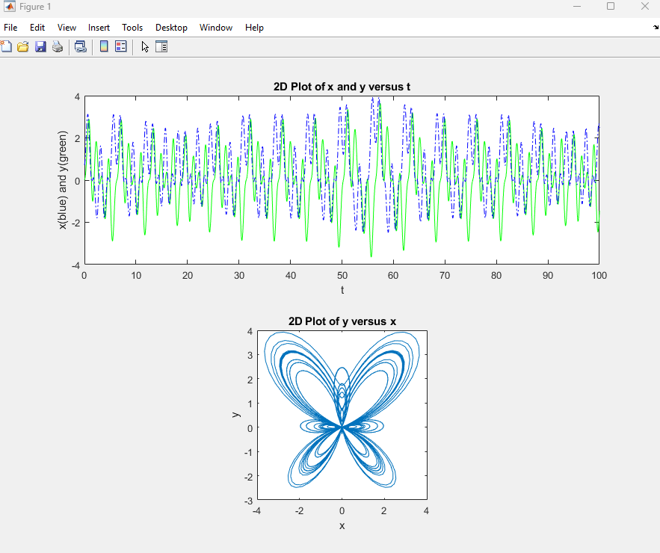

**Question 2**

The purpose of the second question is to draw polar plot (polar function) looks like radar. The drawing was butterfly curve with a dashed red line.

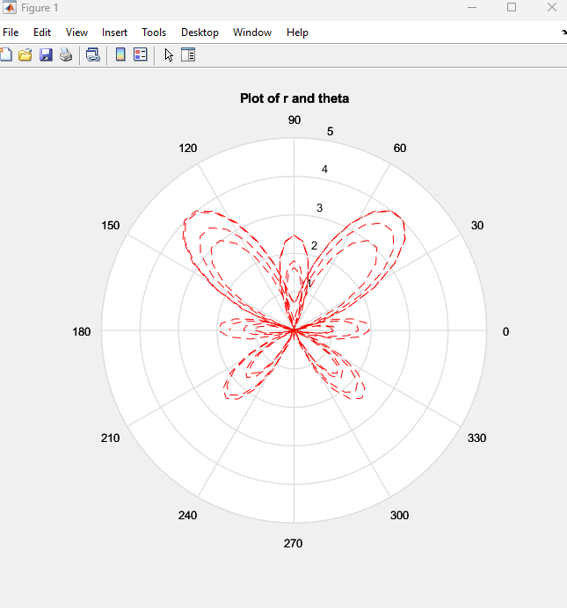

**Question 3**

The purpose of third question is to calculate sin(x) value and see the percent relative error by the input values. x and number of terms values are chosen by the user.

Input for x = 0.9

Input for numberOfValues = 10

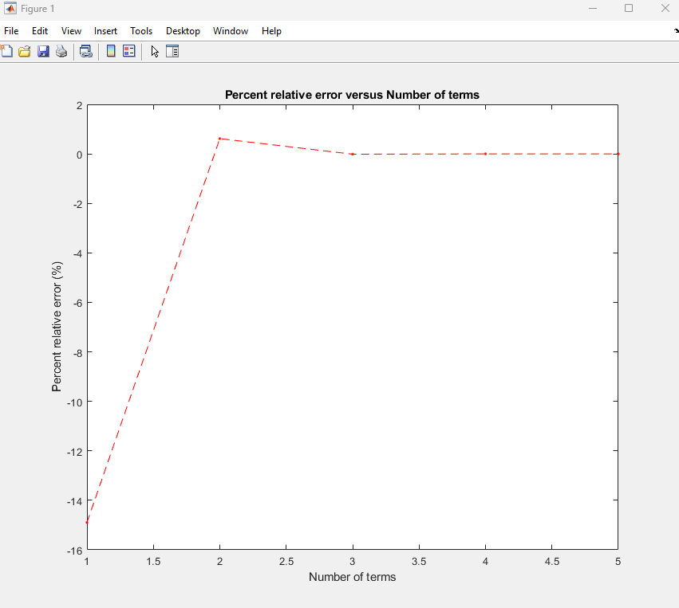

**Question 4**

The purpose of the fourth question is to make a function which returns minimum and maximum values of one of the given 3 equations. After chosen one of them function draws a plot. x values has taken and used to find the y values. Here are the equations.

*Equation 1*

[minf, maxf]=minAndMax(@(t) 8*exp(-0.25*t).*sin(t-2), 0, 6*pi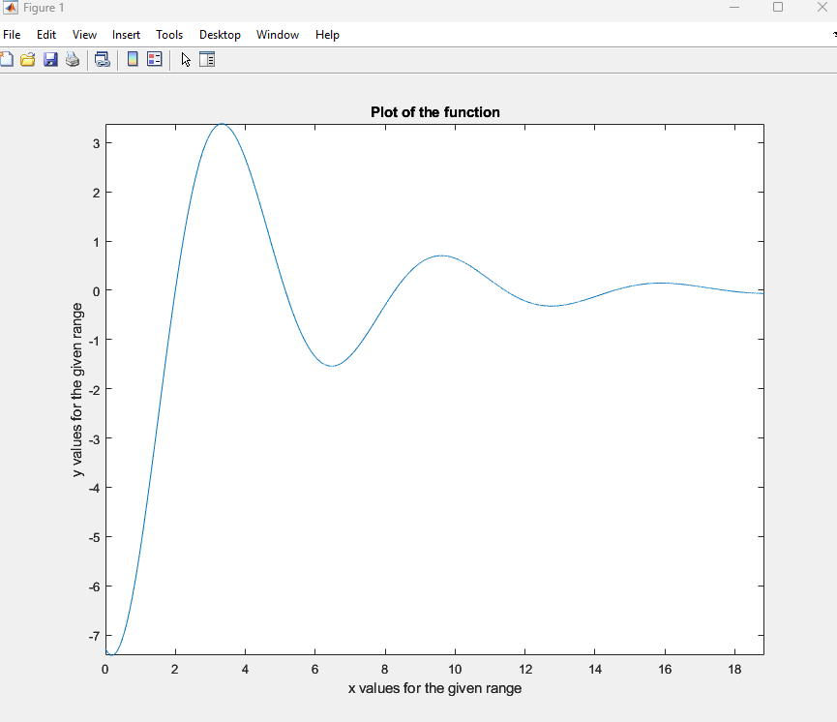)

*Equation 2*

[minf, maxf]=minAndMax(@(x) exp(4*x).*sin(1./x), 0.01, 0.2)

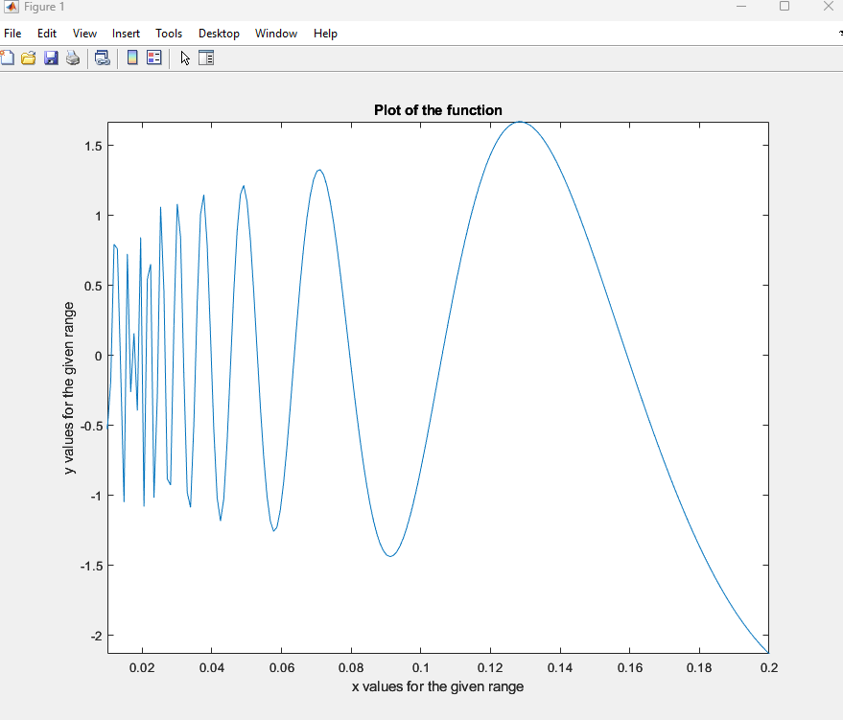

*Equation 3*

[minf, maxf]=minAndMax(@(t) humps(t), 0, 2)

